Assignment # 4  
JAVASCRIPT

**VARIABLE Names: legal & illegal**

1. Declare 3 variables in one statement.
2. Declare 5 legal & 5 illegal variable names.
3. Display this in your browser
4. A heading stating “Rules for naming JS variables”
5. Variable names can only contain ______, ______, ______ and ______.  
   For example **$my_1stVariable**
6. Variables must begin with a ______, ______ or  
   _____. For example **$name, _name** or **name**
7. Variable names are case _________
8. Variable names should not be JS _________

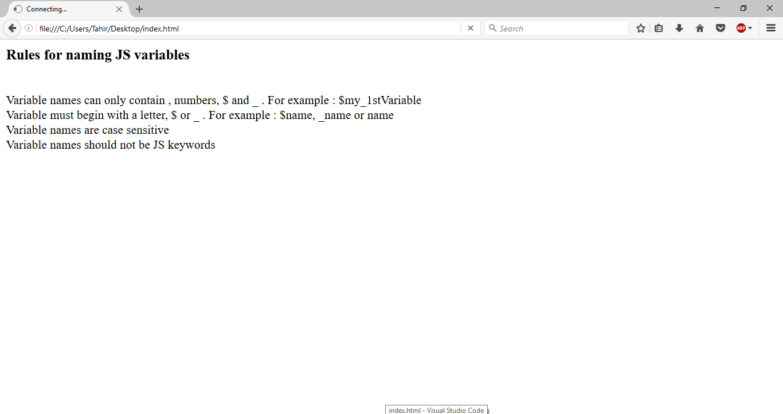

**-- END --**